***Pythagorean Theorem***

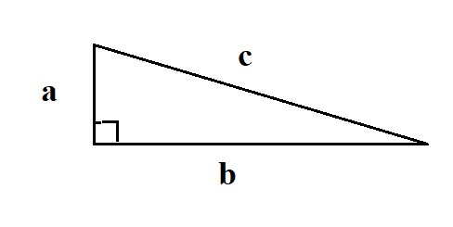

In all right triangles:

a2 + b2 = c2

**Example A**

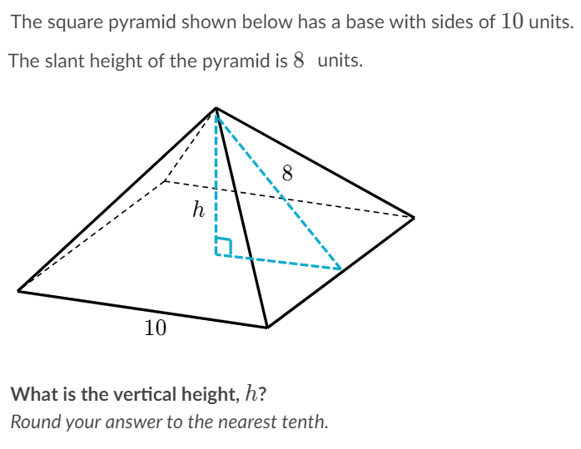**Can you see that this section is half of the side marked 10 units? That is 5 units long.**

We will use Pythagorean Theorem: a2 + b2 = c2  for this triangle.

**a = *h,* b= 5 and c = 8**

**h2 + 52 = 82**

**h2 + 25 = 64** subtract 25 from

both sides of the equation.

**h2  = 39** now take the square root of both sides

***h =* 6.2449….** rounded = 6.2

**Example B**

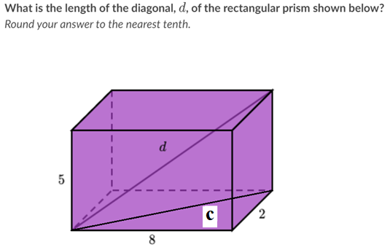

It will take two steps to solve this problem.

Step 1 find the length of the diagonal ‘c’

We will use Pythagorean Theorem: a2 + b2 = c2  for this triangle.

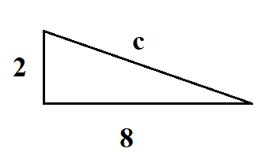

22  + 82 = C2

4 + 64 = C2

68 = C2

8.246211251… = c

STEP 2 We now can find ‘d’ using this triangle

We will use Pythagorean Theorem: a2 + b2 = c2  for this triangle 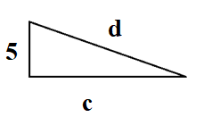too.

52  + C2 = d2

25 + (8.246211251)2 = d2

25 + 68 = d2

9.6436… = *d*

**Example C**

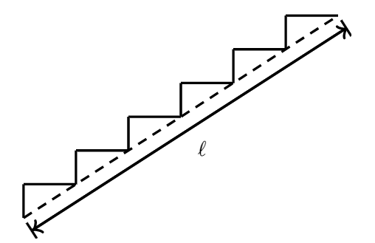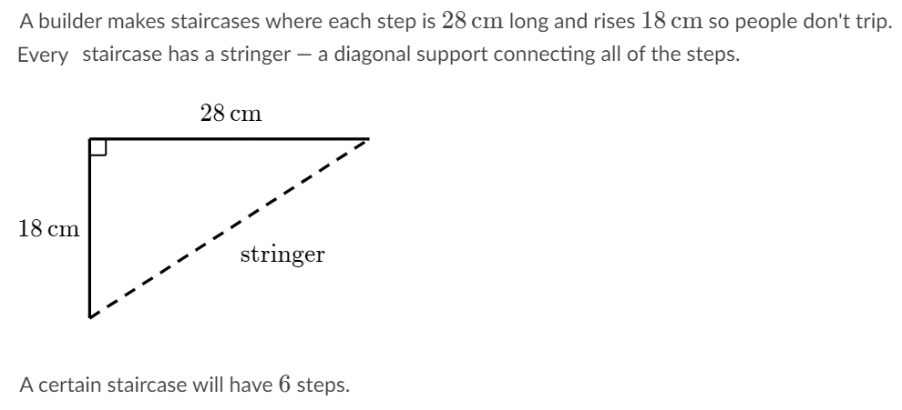

**What is the length l of the stringer for this taircase?**  
Round your answer to the nearest tenth of a centimeter.

We will use Pythagorean Theorem: \a2 + b2 = c2  for this triangle.

182 + 282 =**l** 2

324 + 784 = **l** 2

1108 = **l** 2 Take the square root of both sides of the equation to get 33.2866… = **l**

But we need 6 of this length, so multiply 33.266 by 6 to get 199.7198…

rounded it will be 199,7cm

**Example D**

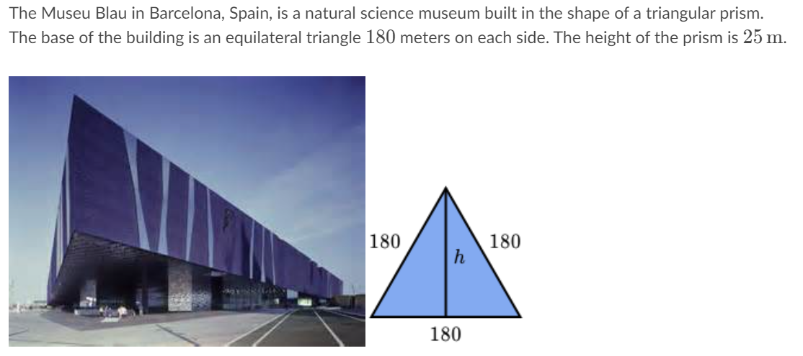

Look at the base of the triangle, it is 180, but it is split in half by the vertical line marked ‘h.’ So half of 180 would be 90 and we can use that to find ‘h’ with the Pythagorean Theorem. We will use Pythagorean Theorem: a2 + b2 = c2  for this triangle.

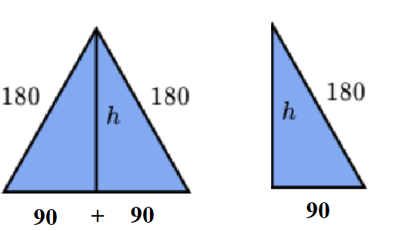 We only need half of the entire triangle to figure out the height ‘h’

a2 + b2 = c2  which is h2 + 902 = 1802

h2 + 8100 = 32400 subtract 8100 from both sides

h2 = 24300 take the square root of both sides

h = 155.88745…. or rounded = 156

**EXAMPLE E**

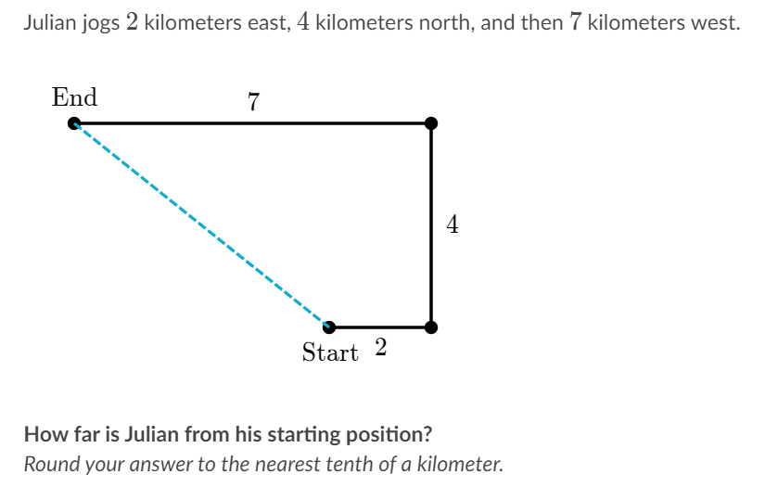

Let’s make this easier by drawing in some lines…

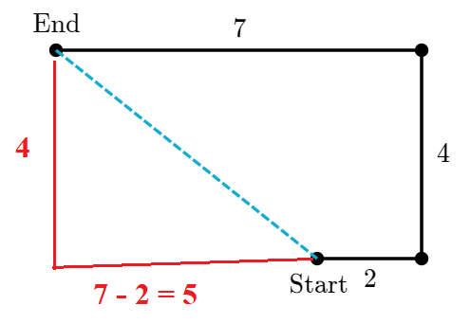 Now we can use a2 + b2 = c2  to find the distance from ‘Start’ to ‘End’

42 + 52 = our distance2

16 + 25 = d2

41 = d2 take the square root of both sides

6.40312… = d rounded is 6.4

***Special Right Triangles***

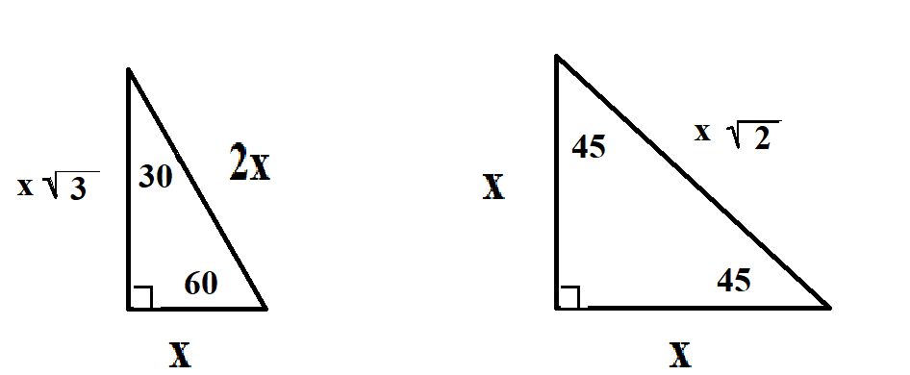

**EXAMPLE 1**

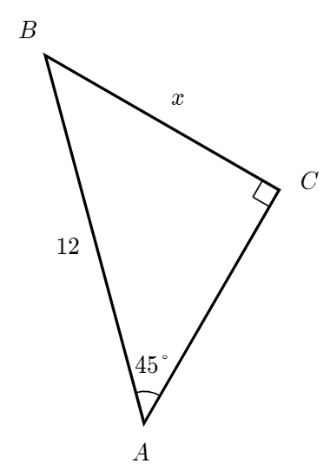

**How long is ‘BC’?**

Using the 45-45-90 triangle above as a model we will get

$x\sqrt{2} =12$ divide both side by $\sqrt{2}$

$x= \frac{12}{\sqrt{2}}$ Multiply numerator and denominator by $\sqrt{2}$

$x= \frac{12\sqrt{2}}{2}$ simplify

$x=6\sqrt{2}$ = ANSWER

**EXAMPLE 2**

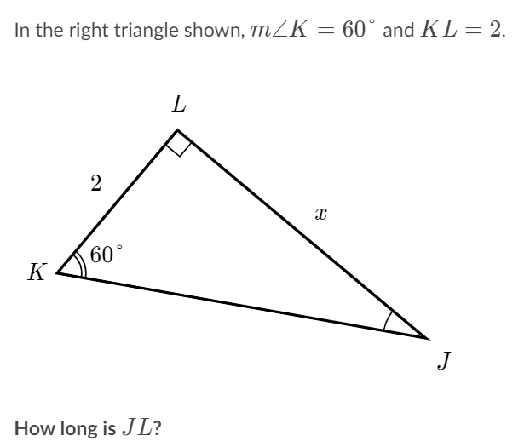

**Using the model above we can see the x will be $2\sqrt{3}$,** because

The “KL” segment is 2 and the “LJ” segment is always the same length, but times $\sqrt{3}$

ANSWER = $2\sqrt{3}$ **= *JL***